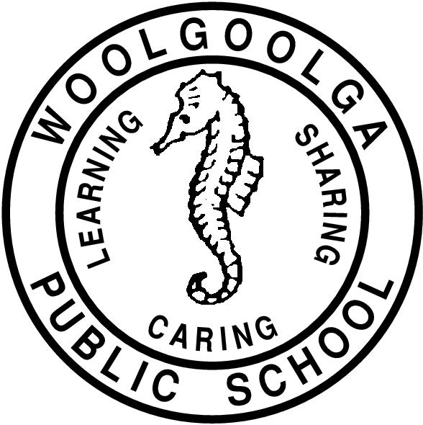

Woolgoolga Public School

Student Wellbeing Procedures

Endorsed by the P&C and
Student Parliament
June
2023
Student Wellbeing and Management

Woolgoolga Public School
Scarborough Street, PO Box 523,
Woolgoolga NSW 2456
Ph: 02 6654 1305 Fax: 02 6654 0028
Email: woolgoolga-p.school@det.nsw.edu.au

RATIONALE
Woolgoolga Public School seeks to provide quality education for all students. Students are encouraged to become self-directed, lifelong learners who will create a positive future for themselves and for the wider community.

Woolgoolga Public School is a safe environment where the whole school community is respected.

Our school embraces the philosophy of the school motto and Positive Behaviour for Learning.
DEFINITION
Welfare at Woolgoolga Public School encompasses school community practices that meet the personal, social and learning needs of all students by providing a safe and respectful environment. All members of the school environment are asked to act in a responsible and respectful manner towards others.
OUR WELLBEING PROCEDURES

- School Rules – encompassing the core expectations of the Behaviour Code
- Managing Student Behaviour
- Strategies to promote positive behaviour
- Recognising and reinforcing student achievement, positive behaviour and learning

CORE RULES FOR STUDENTS IN NSW GOVERNMENT SCHOOLS
Students in NSW government schools are provided with a high-quality education so that they may learn to the best of their ability and become self-disciplined, tolerant, enterprising and contributing members of the school and community. Core expectations for student behaviour have been developed to establish consistent expectations in all government schools in support of these aims. These expectations are based on our core values of integrity, excellence, respect, responsibility, cooperation, participation, care, fairness and democracy. The critical role of parents and care-givers is recognised as the primary influence on each child’s character and behaviour and as essential partners in supporting the core expectations and the successful education of their children.
These core expectations are an integral part of our policy and are reflected throughout.
All students in NSW government schools are expected to:
● Attend every school day, unless they are legally excused, and be in class on time and prepared to learn
● Maintain a neat appearance, including adhering to the requirements of the school’s uniform policy
● Behave safely, considerately and responsibly, including when travelling to and from school
● Show respect at all times for teachers, other school staff and helpers, including following class expectations, speaking courteously and cooperating with instructions and learning activities
● Treat one another with dignity and respect and resolve conflict respectfully, calmly and fairly
● Care for property belonging to themselves, the school and others.
Behaviour that infringes on the safety of others, such as harassment, bullying and illegal or anti-social behaviour of any kind, will not be tolerated.
Link to the full copy of the Behaviour Code for students:
https://education.nsw.gov.au/public-schools/going-to-a-public-school/translated-documents/behaviour-code-for-students

- SCHOOL RULES
To establish positive behaviour for learning at Woolgoolga Public School, the school community will uphold the school motto ‘Learning, Caring and Sharing’ through adhering to the school rules:
- Be Respectful
- Be Safe and
- Be a Learner
Students at Woolgoolga Public School will:

- keep themselves and others safe
- move safely around the school
- be in the right place at the right time
- show pride in their school
- be kind, helpful and cooperative
- value each other
- arrive on time
- be ready to learn
- do their best

Be SAFE | Be RESPECTFUL | Be a LEARNER
Keep yourself and others safe  Move safely around the school  Be in the right place at the right time | Show pride in your school  Be kind, helpful and cooperative  Value each other | Arrive on time  Be ready to learn  Do your best

- MANAGING STUDENT BEHAVIOUR
Classroom Procedures
Classroom rules and expectations reflect the school rules: ‘Be Respectful, Be Safe and Be a Learner’. They are explicitly taught to students, regularly referred to and displayed in the classroom. All staff use consistent language and reinforce rules at musters and assembly according to the weekly focus.

The classroom discipline procedures outlined below are clearly displayed.

Steps in the procedure:

- Rule Reminder/ Warning
Reflect on school rules. (Which rule are you breaking?)
- Quiet Area
Remove to quiet area in the classroom
- Buddy Class
Directed to “buddy class”
- Assistant Principal
Directed to Stage Supervisor
- Principal
Directed to Principal

Please Note:
- Parents/carers may be contacted by the classroom teacher, Stage Supervisor (Assistant Principal) or the Principal at any stage
- Continued disobedience and/or aggressive behaviour is referred directly to the Deputy Principal or Principal
- The Deputy Principal/Principal may exercise the right to suspend or expel a student consistent with DoE guidelines

These strategies assist students who have made choices resulting in a breach of the school expectations or Behaviour Code for Students.

https://education.nsw.gov.au/student-wellbeing/attendance-behaviour-and-engagement/behaviour-support-toolkit/support-for-teachers

Playground Procedures
Playground expectations reflect the school rules: ‘Be Respectful, Be Safe and Be a Learner’. They are explicitly taught to students, regularly referred to and displayed in the appropriate area.
Steps in the procedure:
- Rule Reminder
Teacher reflects on school rules with student. (Which rule are you breaking?)
- Playground Behaviour Incident Report
Teachers enter information of playground incident into Sentral and place student into reflection according to level system
- Review of Playground Incident Reports
Reports reviewed weekly/fortnightly by Deputy Principal/Principal. A decision on course of action made.

These actions may include:
- Discuss unacceptable behavior with student
- Contact parent/carer via phone or letter
- Structured play time
- Reflection
- Parent Meeting
- Referral to Learning Support Team (LST)
- The Deputy Principal/Principal may exercise the right to suspend or expel a student consistent with DoE guidelines

Woolgoolga Public School - Restorative Practices (Reflection) and Levelled System

MINOR BREACHES - 1  Teacher responds at the point of need with immediate response. | MINOR BREACHES - 2  Teacher responds at the point of need with immediate response. E.g sit with teacher, reflect .
SAFE  ● Climbing trees (with exception of tree in K-2 area)  ● Running on gardens/concrete  ● No sun safe/school hat in playground  ● Out of bounds  ● Breaking playground rules-for example not wearing shoes, kicking footballs in inappropriate or dangerous areas  RESPECTFUL  ● Littering  ● Disruptive, late for lines  ● Interfering in others games/work  ● Throwing food – not at others  ● Put down-one off  ● Taking equipment from others  ● Bad manners towards peers  ● Unacceptable use of school equipment  LEARNER  ● Failure to follow sensible school procedures i.e non-reporting taking action in own hands  ● Fooling around at bubblers  ● Eating in wrong area  ● Using equipment at wrong time  ● Playing in toilets | SAFE  ● Taking other students’ hats  ● Not sitting at bus lines  ● Throwing food at others  ● Throwing rocks/sticks not at others  ● Inappropriate touching (Minor pushing, tripping, shouldering)  RESPECTFUL  ● Inappropriate gestures  ● Failing to follow instructions  ● Disrupting assembly lines  ● Inappropriate language  ● Teasing or putting others down  ● Spitting  LEARNER  ● Repeated warnings of any minor breaches  ● Other minor playground indiscretions
REFLECTION - LEVEL 1  Students attend one session of reflection.  Teacher records the incident on SENTRAL, informs the student and applies reflection to the incident.  Deputy Principal marks reflection roll and implements restorative practices. | REFLECTION - LEVEL 2  Students attend two sessions of reflection and have designated play areas for two days. Failure to report to designated play area will result in additional reflection time.  Teacher records the incident on SENTRAL and notifies the Assistant Principal. Teacher informs the student, applies reflection to the incident.  Deputy Principal marks reflection roll and implements restorative practices. The Deputy Principal may implement formal caution of suspension at this point.  Students on level 2 are not permitted to attend events or represent the school without the permission of senior executives.
SAFE  ● Throwing objects at others  ● Tripping another deliberately  ● Leaving school grounds without permission  RESPECTFUL  ● Disrespect to teachers, peers, and other staff/visitors  ● Vandalism (minor)  ● Theft  ● Bullying behaviour including both verbal and non-verbal and physical  ● Serious disobedience towards staff  ● Spitting on a student  LEARNER  ● Repeated minor breaches of rules | SAFE  ●Throwing rocks and injuring someone  ● Violence capable of causing injury  ● Throwing objects in a forcible manner which also may have injured someone  ● Physical aggression  ● Possession or use of vapes, cigarettes or alcohol  RESPECTFUL  ● Abusive language directed at staff or student  ● Repeated or extreme disobedience  ● Vandalism – major  ● Continual bullying  ● Cyber bullying including explicit emailing and inappropriate use of IT resources at School  LEARNER  ●Repeated Level 1 behaviour
LEVEL 3 SUSPENSION – last resort

Students are suspended in line with NSW Department of Education Policy for serious or frequent incidents. Suspensions are at the determination of the principal and may be up to 10 days.
Formal caution of suspension may be given prior to suspension.
K-2 – Up to 5 Days Years 3 - 6 – Up to 10 days, Additional days will be up to the discretion of the DEL

SAFE
● Criminal behaviour related to the school
● Physical violence
● Possession or use of illegal substance
● Prohibited weapon, firearm, or knife
● Use of an implement as a weapon
RESPECTFUL/LEARNER
● Persistent or serious misbehavior
● Racism
FURTHER EXPLANATION OF LEVELS
Level 1
Students are placed on Level 1 for a 1 session of reflection. Students will return to Level 0 after completion of reflection plus 1 week free from unacceptable behaviour at school. Students may progress to Level 2 if behaviour continues during the period of 1 week.

Level 2
Students are placed on Level 2 for a 2 sessions of reflection and two days of designated play space. Students must report to the teacher on duty and be signed off. On a Level 2 students may lose all extra privileges which includes all excursions, sporting team activities, competitions, visiting performances and any other events at the senior executive’s discretion. Students return to Level 0 after completion of reflection plus 1 week free from unacceptable behaviour at school. Parents are contacted by the Deputy Principal to inform them of Level 2 and formal caution of suspension (if warranted). Behaviour Management Plans are implemented/reviewed at this level by the classroom teacher in consultation.

Level 3
Students will be suspended on a Level 3. On a Level 3 students may lose all extra privileges which includes all excursions, sporting team activities, competitions, visiting performances and any other events at the senior executive’s discretion. On their return to school a documented program of improvement is implemented involving all stake holders. A loss of privileges may be part of this plan until positive behaviour is displayed. A student returning from suspension will return to level 0 with designated play space for 3 days.

Serious and ongoing negative behaviours of concern may lead to an expulsion from school according to NSW DoE policies.

Excursion and Activities
The priority for all excursions/activities is the safety and wellbeing of all students and staff. Students on excursions/activities interact with the public and are representative of their school and community. Students should be briefed on the expected standards of behaviour and the school's discipline code or school rules. Policies and procedures relating to student behaviour, including the behaviour code for students apply while on excursions/activities. Students who consistently display behaviours of concern will be involved in a meeting with their parents and the Deputy Principal/Principal to discuss possible participation. Students will not be able to attend if an unacceptable safety risk is determined. In this case, non-attending students will be provided with an alternative program. Students on suspension are not allowed to attend school excursions/activities.

Reflection
Reflection enables students an opportunity to reflect on their behaviour and be provided with strategies to support positive choices. This is a structured session guided by the Deputy Principal to ensure the student has the appropriate opportunity to reflect on the school expectations and rules. The reflection room is only to be used for clear breaches of the school expectations determined by level system Teachers will develop strategies to deal with misbehaviour in the classroom as part of their classroom management practices. Each student needs to be recorded on Sentral for reflection by the teacher on duty. Students will reflect on their behaviour using a variety of strategies.

Suspension and Expulsion
Consequences for serious or ongoing breaches of the school rules may involve:
- The issuing of a formal caution suspension letter
- In-school suspension
- Suspension
- Expulsion

Suspension is not intended as a punishment. Suspension allows time for the school to plan appropriate support for the student to successfully re-engage with learning at school. Suspension can be a critical safeguard if student behaviour poses a risk to the safety, health, learning and wellbeing of others. In some situations, the Principal may decide that a suspension is the most appropriate response.

(Student Behaviour Procedures K-12 NSW Dept of Education Policy 2022) https://education.nsw.gov.au/policy-library/policies/pd-2006-0316

Parent link https://education.nsw.gov.au/student-wellbeing/attendance-behaviour-and-engagement/behaviour-support-toolkit/support-forparents/my-child-is-suspended

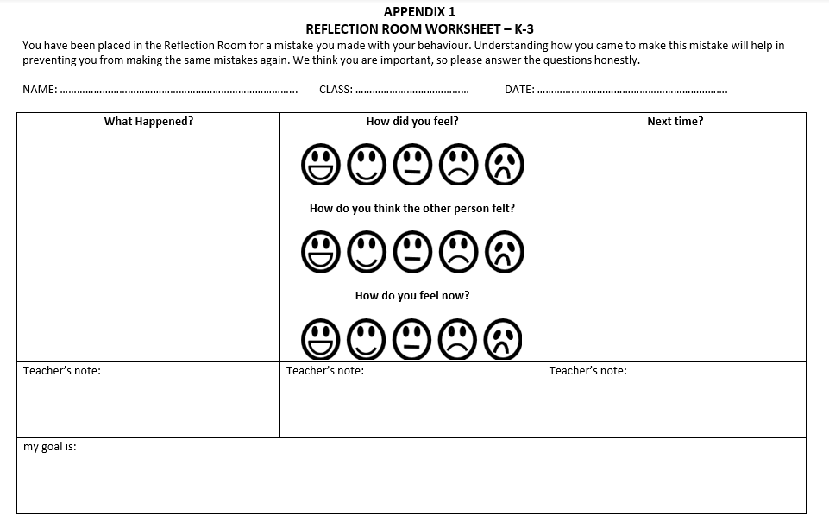

K-2 Reflection Room

REFLECTION ROOM WORKSHEET – Senior
You have been placed in the Reflection Room for a mistake you made with your behaviour. Understanding how you came to make this mistake will help in preventing you from making the same mistakes again. We think you are important, so please answer the questions honestly.
NAME : …………………………………………… CLASS: ………………..…… DATE:……………………………………….

What happened that caused you to be here today?
……………………………………………………………………………………………………………………………………………
……………………………………………………………………………………………………………………………………………
Why did you act in this way?
……………………………………………………………………………………………………………………………………………
Who was affected by your behaviour (students/staff)?
……………………………………………………………………………………………………………………………………………
……………………………………………………………………………………………………………………………………………
What will you do in the future to act in a safer or more appropriate way?
……………………………………………………………………………………………………………………………………………
……………………………………………………………………………………………………………………………………………
Who did this behaviour affect and how could you make this better?
……………………………………………………………………………………………………………………………………………
……………………………………………………………………………………………………………………………………………

Which ones do you need to work on?
At Woolgoolga we follow a set of expectations. We are:
- Safe
- Respectful
- Learners
My goal is to ……………………………………………………………………………………………………………………………………………
……………………………………………………………………………………………………………………………………………
Student …………………………………………………… Teacher ………………………………………………………

3.STRATEGIES TO PROMOTE POSITIVE BEHAVIOUR FOR EFFECTIVE LEARNING
Students are assisted to develop positive social behaviours through a range of proactive strategies. These strategies may include:
- Daily check-ins
- Whole school rule focus – fortnightly rotation
- Mindfulness activities
- Developing conflict resolution/social skills training – Peer Support program, PD/H/PE curriculum
- Using Zones of Regulation to recognise and respond to emotions
- Anxiety Project to teach and foster resilience
- Referral to Learning Support Team for further assistance - behaviour assessment/support; counselling
- A complex case management strategy may need to be developed and implemented by the Learning Support Team, including interagencies and support personnel.
- Mentoring programs including supported play/structured play
- Playground monitoring cards
- Risk Management Plan
- Behaviour Management Plan
- Personalised Learning and Support Plans

4.RECOGNISING AND REINFORCING STUDENT ACHIEVEMENT, POSITIVE BEHAVIOUR AND LEARNING

Students will be recognised for achievement, positive behaviour and learning in the following areas:

All Learning Environments

“Win Bin” – awarded to students for displaying school rules
  - A teacher must sign these at the time of presentation.
  - Students then place these in the appropriate win bins (K-2 or 3-6).
  - Weekly prizes or canteen vouchers are drawn from these bins – 3 vouchers for K-2 and 3 vouchers for 3-6.
Achievement Award – awarded to students for recognition of effort, citizenship and academic achievement.
- Classroom teachers will receive an award pack (100 awards) per term. This must be exhausted each term to ensure consistency across K-6. Teachers cannot obtain more awards throughout the term.
- Merit Certificate - awarded to students after receiving five achievement awards.
- Bronze Award – awarded to students after receiving two merit certificates.
- Silver Award – awarded to students after receiving four merit certificates.
- Gold Award – awarded to students after receiving eight merit certificates.

Reward activity at the end of term, determined by the class teacher. This activity will be approved by the Assistant Principal supervising the grade/stage.

Sport
Aussie Sports Awards
- awarded to students for good sportsmanship, cooperation, participation, effort or skill development during fitness and sport sessions
- teacher must sign these at the time of presentation
Aussie Sport Ribbon
  - awarded to students for five Aussie Sports Awards
Aussie Sports Banner
  - awarded to students for three Aussie Sports Ribbons
Attendance
Students are encouraged the attend school regularly. Positive attendance is rewarded by:
- Random Positive Attendance Days – yellow slips are given out to students who are on time for school on the random positive attendance days. These students then go into an end of term draw where school merchandise prizes are presented to 3 students in each grade
- 95% attendance or above awards are presented to students at the end of each term

